CSA0924 JAVA PROGRAMMING
CO1 - ASSESMENT TOOL – 2 - FLOWGORITHM FLOWCHART AND PSEUDO CODE
NAME: Sai Datta Karanam Reg.No. : 192472016

Question 1: Read a number from 1 to 7 and display the corresponding day of the week using a selection statement.
Algorithm:
- Start.
- Declare an integer variable day.
- Read the value of day from the user.
- Check the value using an if-else ladder:
- If day = 1, display Monday.
- If day = 2, display Tuesday.
- If day = 3, display Wednesday.
- If day = 4, display Thursday.
- If day = 5, display Friday.
- If day = 6, display Saturday.
- If day = 7, display Sunday.
- Otherwise, display Invalid Input.
- Stop.
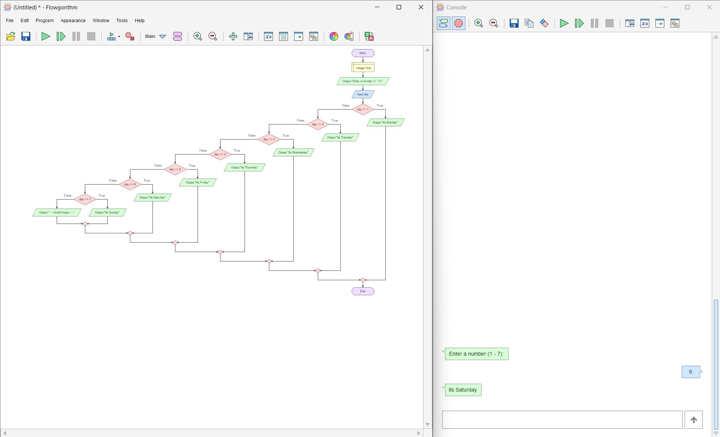
Flowgorithm Flowchart:
Test Case | Input | Expected Output | Actual Output | Result
1 | 1 | Monday | Monday | Pass
2 | 5 | Friday | Friday | Pass
3 | 7 | Sunday | Sunday | Pass
4 | 0 | Invalid Input | Invalid Input | Pass
5 | 9 | Invalid Input | Invalid Input | Pass
Test Cases:

Equivalent Java Concept Used:
The Flowgorithm program uses an if-else selection statement, which directly corresponds to Java's if-else-if ladder.
- Variables (int day)
- Input using the Scanner class
- Selection statement (if-else-if)
- Output using System.out.println()
Conclusion:
The Flowgorithm program was successfully developed using a selection statement. It correctly displayed the corresponding day for valid inputs and produced an "Invalid Input" message for values outside the range of 1 to 7. The Flowgorithm logic maps directly to Java's if-else-if statement.

Question 2: Read a number and determine whether it is an Armstrong number for a three-digit input.
Algorithm:
- START.
- Declare four integer variables: num, temp, digit, and sum.
- Read the input number num.
- Assign temp = num and initialize sum = 0.
- Repeat the following steps while temp > 0:
- Find the last digit using digit = temp % 10.
- Calculate the cube of the digit and add it to sum.
- Remove the last digit using temp = temp / 10.
- Compare sum with num
- If both are equal, display "Armstrong Number".
- Otherwise, display "Not an Armstrong Number".
- STOP
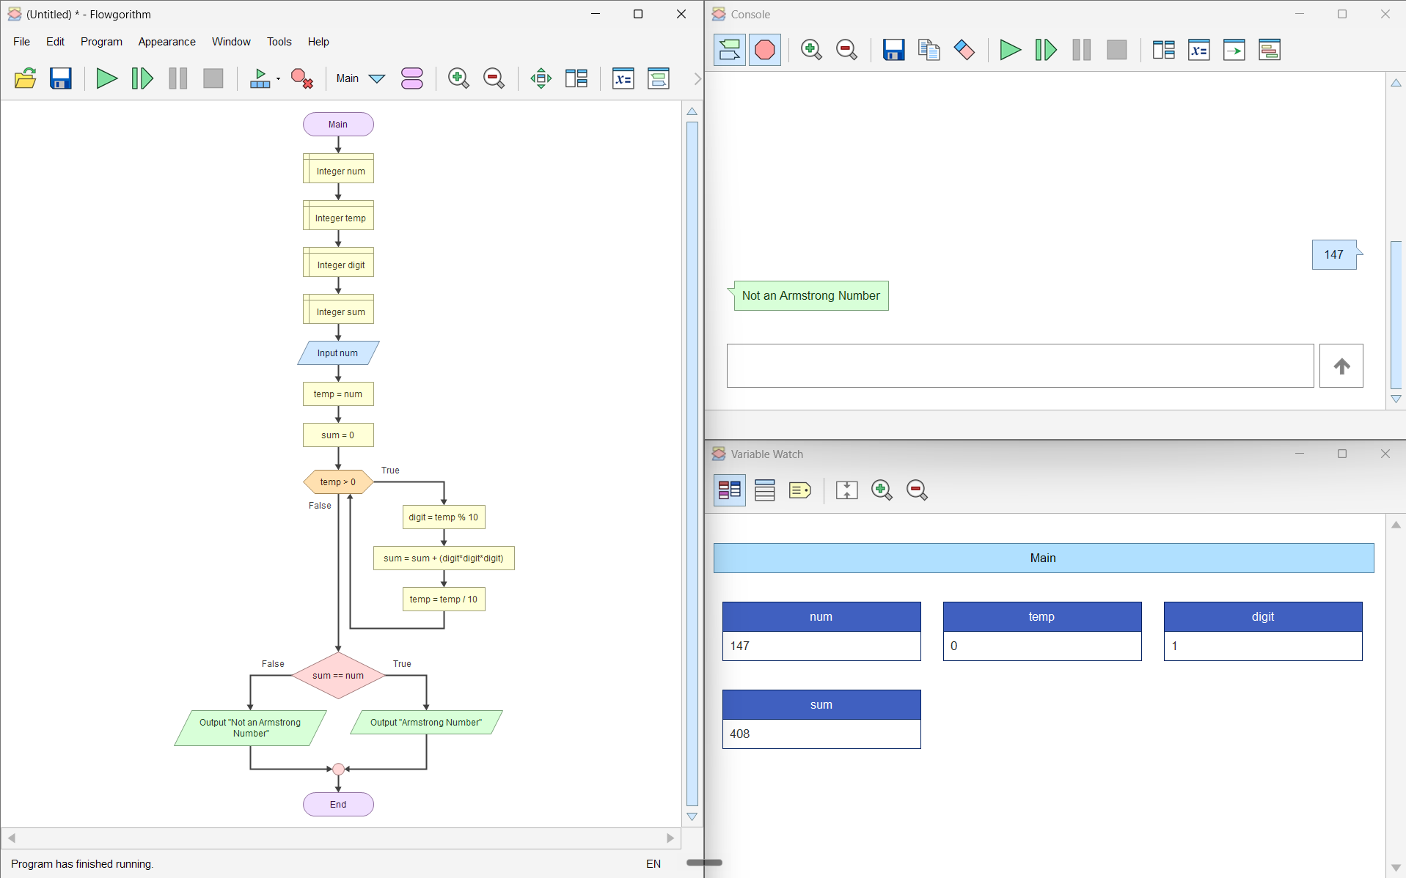
Flowgorithm Flowchart:

Test Cases:
Test Case | Input | Expected Output | Result
TC1 | 153 | Armstrong Number | Pass
TC2 | 370 | Armstrong Number | Pass
TC3 | 371 | Armstrong Number | Pass
TC4 | 407 | Armstrong Number | Pass
TC5 | 123 | Not an Armstrong Number | Pass
TC6 | 200 | Not an Armstrong Number | Pass
TC7 | 999 | Not an Armstrong Number | Pass

Equivalent Java Concept Used:
The Flowgorithm program uses concepts that directly correspond to Java programming. Variable declarations are equivalent to Java's int data type, input is handled using the Scanner class, output is displayed with System.out.println(), assignments use the = operator, the while loop is used for repetition, the if-else statement is used for decision-making, and arithmetic operators such as %, *, +, and / are used to extract digits and calculate the Armstrong sum.

Conclusion:
The program successfully determines whether a given three-digit number is an Armstrong number by extracting each digit, calculating the sum of their cubes, and comparing the result with the original number. It demonstrates the use of selection statements (if-else), iteration (while loop), arithmetic operations, and variable manipulation in Flowgorithm.

Question 3: Create a function reverseNumber and reuse it in another function isPalindrome. Demonstrate function composition in the flowchart.
Algorithm:
- Start.
- Read an integer num.
- Call the function isPalindrome(num).
- Inside isPalindrome, call the function reverseNumber(num) to obtain the reversed number.
- Compare the reversed number with the original number.
- If both are equal, display "Palindrome Number".
- Otherwise, display "Not a Palindrome Number".
- Stop.
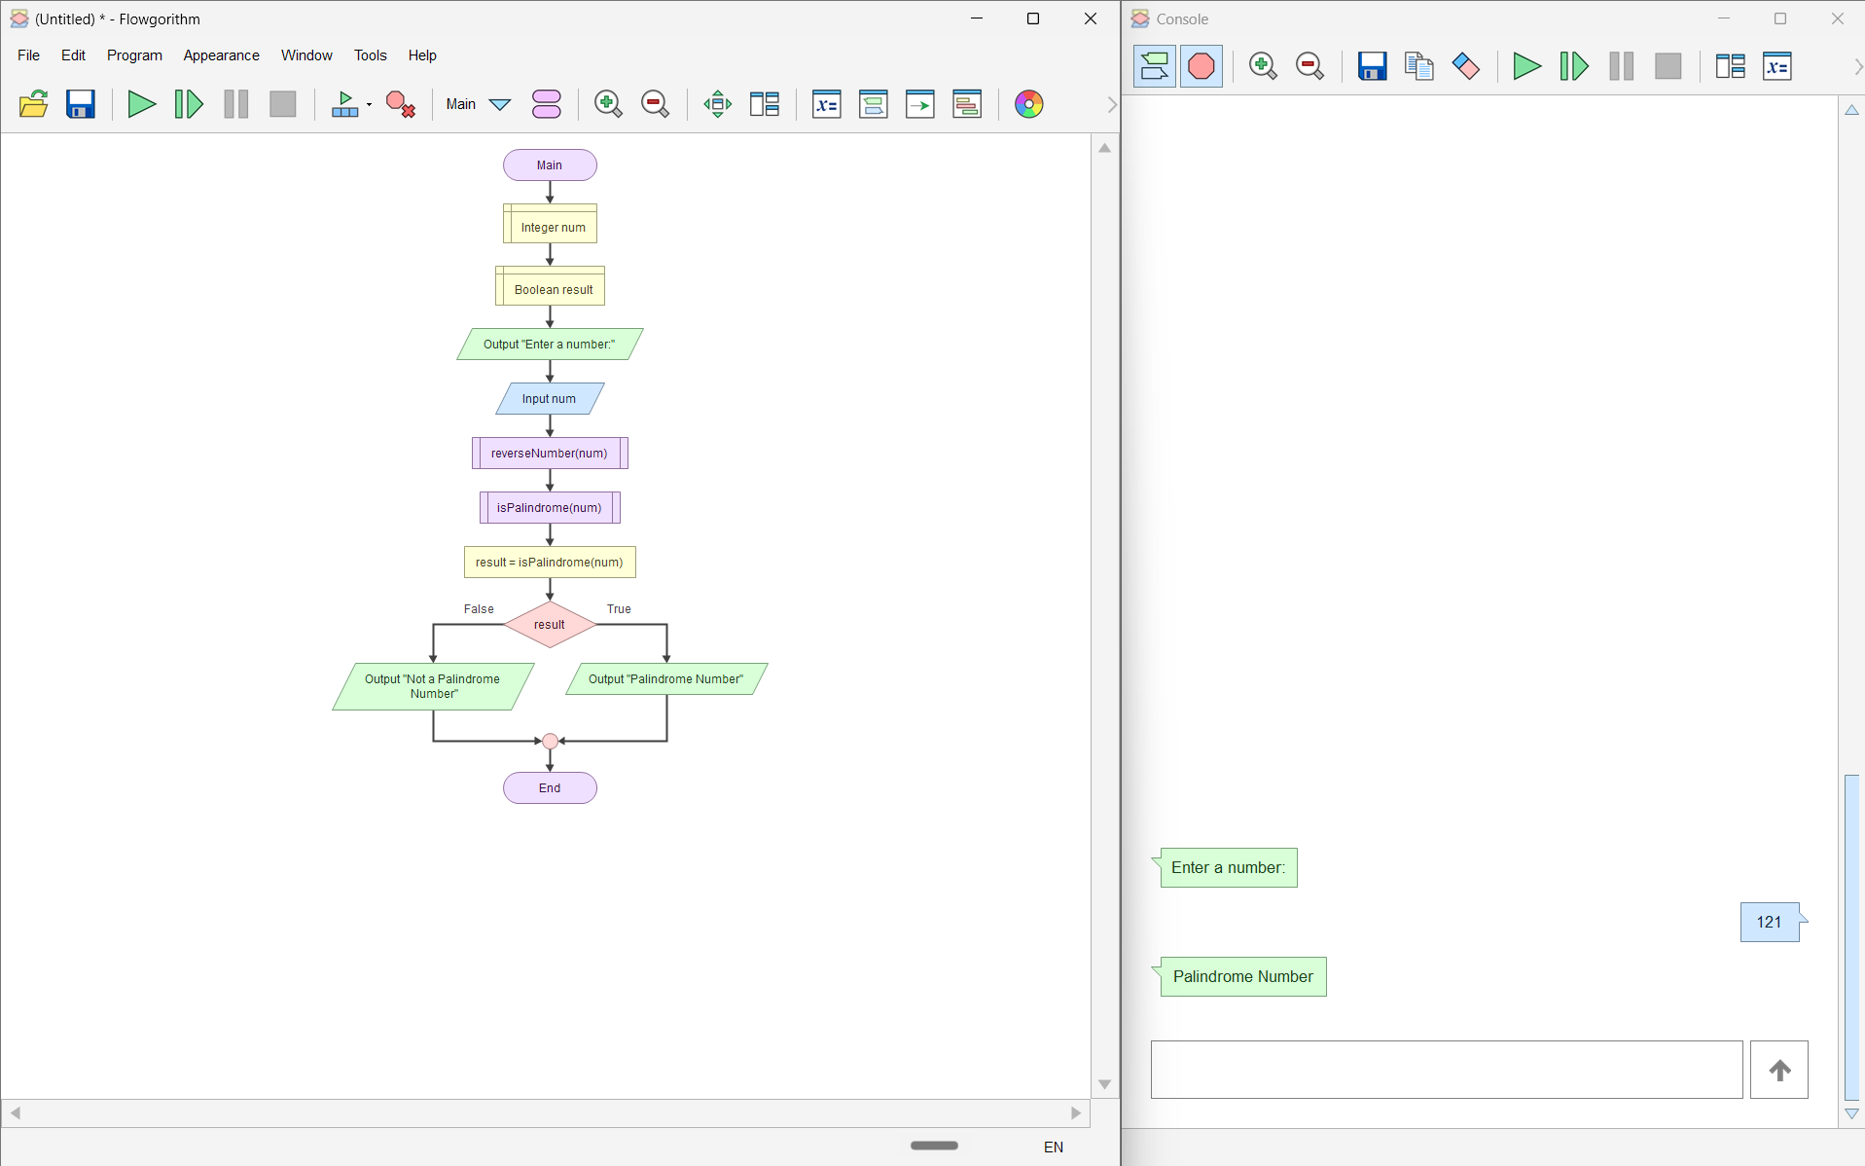
Flowgorithm Flowchart:
Test Case:
Test Case | Input | Expected Output | Result
TC1 | 121 | Palindrome Number | Pass
TC2 | 12321 | Palindrome Number | Pass
TC3 | 1221 | Palindrome Number | Pass
TC4 | 123 | Not a Palindrome Number | Pass
TC5 | 45654 | Palindrome Number | Pass

Equivalent Java Concept Used:
This Flowgorithm program demonstrates function composition using two functions: reverseNumber() and isPalindrome(). It corresponds to Java methods where one method (isPalindrome) calls another method (reverseNumber). It also uses int variables, while loops, if-else statements, return values, and method calls.

Conclusion:
The program demonstrates function composition by reusing the reverseNumber() function inside isPalindrome(). This modular approach improves code reusability, readability, and makes the logic easier to maintain in both Flowgorithm and Java.

